**Fundamentals/Basic/Advance Plotting**

**Enabling Objectives:**

* DEFINE line of position
* IDENTIFY ideal Visual and Radar NAVAIDs
* DEFINE fix
* RECALL the LOP requirements for a fix and the symbols used in plotting
* LIST the Navy's required fix intervals
* DESCRIBE the optimal spread of visual LOPs
* USE meridians to plot an LOP
* PLOT a fix using visual LOPs
* DEFINE track, COG, SOG, CMG, and SMG
* DESCRIBE the current triangle
* DEFINE set and drift
* CALCULATE set and drift
* CALCULATE CMG and SMG
* DEFINE estimated position
* PLOT an estimated position using the appropriate symbol
* PLOT a fix using radar ranges
* DEFINE dead reckoning
* LIST the six rules of DR
* PLOT two DRs
* MEMORIZE the speed/time/distance equation
* MEMORIZE the 3-minute and 6-minute rules
* DEFINE running fix
* PLOT a running fix
* DEFINE compensating course and compensating speed
* CALCULATE compensating course and compensating speed
* DEFINE correcting course and correcting speed
* CALCULATE correcting course and correcting speed

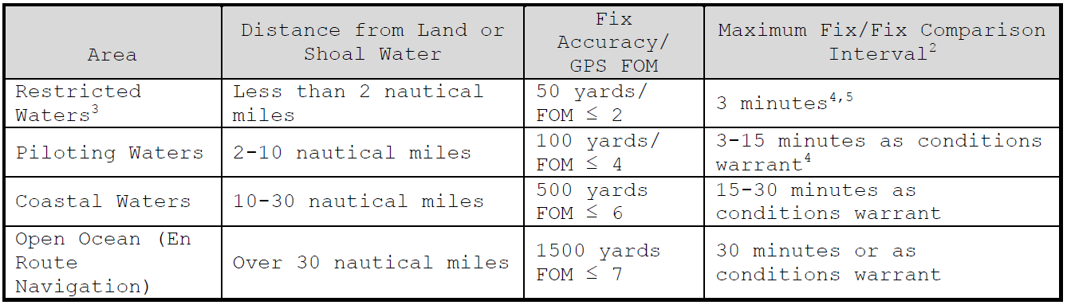

**Line of Position (LOP):** Visual RADAR

**Fix:** Composite Electronic Visual

**Running Fix:**

**Dead Reckoning (DR):**

**Estimated Position:**

**Ordered Course:**

**Ordered Speed:**

**Course Made Good (CMG):**

**Speed Made Good (SMG):**

**Set:**

**Drift:**

**Compensating / Correcting Course & Speed:**

**Speed = Distance / Time:**

**0’**

**1’**

Dome

Spire

Radio Tower

Tank

Tower

Ship Course: 090T

Ship Speed: 5kts

CMG / SMG:

Set & Drift: Compensating Course / Speed:

|  |  |  |  |  |  |
| --- | --- | --- | --- | --- | --- |
|  | **Spire** | **Radar** | **Tank** |  |  |
| 0000 | 030T | 2,000yds | 105T |  |
|  | **Dome** | **Radio Tower** | **Tank** |  |
| 0003 | 020T | 020T | 120T |  |

**30’’**

**0’’**

VA

|  |  |  |  |  |
| --- | --- | --- | --- | --- |
|  | **VA** |  |  |  |
| 0000 | 120T |  |  |
| 0003 | 150T |  |  |
| 0006 | 210T |  |  |